**Rebound effects may undermine benefits of upcycling low-opportunity-cost feed as animal feed in China**

Weitong Long1,2, Xueqin Zhu1*, Hans-Peter Weikard1, Oene Oenema2,3, Yong Hou2*

1Environmental Economics and Natural Resources Group, Wageningen University, Hollandseweg 1, 6706 KN Wageningen, The Netherlands

2State Key Laboratory of Nutrient Use and Management, College of Resources and Environmental Science, China Agricultural University, 100193 Beijing, China

3Wageningen Environmental Research, 6708 PB Wageningen, The Netherlands

⁎ Corresponding author at: Wageningen University, 6706 KN Wageningen, The Netherlands; China Agricultural University, 100193, Beijing, China.

E-mail addresses: [xueqin.zhu@wur.nl](mailto:xueqin.zhu@wur.nl) (X. Zhu); [yonghou@cau.edu.cn](mailto:yonghou@cau.edu.cn) (Y. Hou).

# Abstract

Upcycling low-opportunity-cost feed products (LCFs), such as food waste and food processing by-products, as animal feed could reduce environmental impacts of livestock production, but rebound effects, where lower feed costs lead to livestock production expansion, may diminish these benefits. Using an integrated environmental-economic model, we assessed the global impacts of upcycling LCFs in China’s monogastric livestock production. We found that the upcycling increased monogastric livestock production by 23-36% and raised Chinese economy-wide acidification emissions by 2.5-4.0%. Eutrophication emissions decreased by 0.2% with partial upcycling but increased by 0.2% with full upcycling. Greenhouse gas emissions decreased slightly by 0.5-1.4% through less LCFs in landfills and incinerators, and non-food production contraction. This upcycling accompanying with resource reallocation across the whole economy enhance food security in China without compromising that of its trading partners. Implementing emission taxes to a proper level provides an opportunity to absorb the rebound effects in China and safeguard global food security.

# Keywords

circular food system; food waste; food security; environmental impacts; environmental-economic modelling; rebound effects.

# Main

Animal-sourced food (ASF), such as meat, milk, and eggs, is the main contributor to the environmental impacts of food systems. The surge in demand for ASF, driven by population growth, prosperity, and urbanization, 1,2 is expected to double by 2050, especially in developing countries 3. This surge in livestock production has exacerbated food-feed competition and significantly contributes to the exceedance of the planetary boundaries (PBs) for nitrogen (N), phosphorus (P) and greenhouse gas (GHG) emissions. Currently, 70% of global agricultural land is used for producing animal feed 4, and global livestock production accounts for 13-18% of the total anthropogenic GHG emissions 5, 40% of the ammonia (NH3) and nitrous oxide (N2O) emissions 6, and around 24% of N and 55% of P losses to water bodies 7. It has been shown that the global 1.5°C climate target cannot be achieved without mitigating emissions from food systems 8.

Global food waste has risen from 1.3 to 1.6–2.5 billion tons in recent years despite substantial efforts to reduce food waste 9. A large proportion of food waste ends up in landfills or incinerators, exacerbating GHG emissions and climate change 10. Upcycling low-opportunity-cost feed products (LCFs), such as food waste and food processing by-products, as animal feed is, thus, crucial for reducing environmental impacts and building more circular food systems 11, as it offers a pathway to mitigate land-related pressures 12, alleviate the food-feed competition 11, and reduce emissions from food systems and improper food waste disposal 13. This is because LCFs typically compete less for land and natural resources than human-edible feeding crops 11-13. Increased utilisation of LCFs as feed may also contribute to achieving Sustainable Development Goals (SDGs), including SDG 2 (zero hunger), SDG 6 (clean water and sanitation), SDG 12 (responsible consumption and production), SDG 13 (climate action), and SDG 15 (life on land) 14.

While many studies acknowledge the environmental benefits of increasing LCFs utilisation as feed, significant gaps remain in the existing literature, particularly in three critical areas. First, previous studies 11-13 employing linear optimization models to evaluate the environmental impacts of this circular transition may have overestimated the environmental benefits by disregarding "rebound effect" (or “Jevons paradox”) 15. The rebound effect, where lower feed costs lead to livestock production expansion, may diminish the environmental benefits of feeding animals with LCFs. Second, the “rebound effect” phenomenon has been extensively studied in energy systems 16,17, but its implications in food systems are largely lacking. Although previous studies have explored rebound effects related to a global dietary shift towards plant-based food 18 and halving food loss and waste 19, there is still limited understanding of the rebound effect of upcycling LCFs as animal feed. Third, strateiges to absorb these negative rebound effects resulting from upcycling LCFs as animal feed have not yet been formally explored. Implementing emissions taxes is considered as an effective policy instrument to identify the most cost-effective mitigation pathway for achieving a given emission mitigation target 20-22. For example, many countries, such as the United states, France, Canada, and New Zealand, have implemented various forms of carbon taxes to mitigate GHG emissions 23. China has committed to tackling both global environmental challenges, such as reducing GHG emissions through its pledge for carbon neutrality by 2060 under the Paris Agreement 24,25, as well as addressing local environmental pollution, including emissions of acidification and eutrophication pollutants, to meet the reduction targets set in the “14th Five-Year Plan” 26. It remains unclear by how much rebound effects may influence the expected benefits of upcycling LCFs as animal feed.

In this study, we fill these gaps and contribute to the existing literature by using an integrated environmental-economic modelling approach based on the applied general equilibrium (AGE) models to assess the environmental and economic consequences of upcycling LCFs in China’s monogastric livestock production as feed in a global context. Next, we explore how implementing economy-wide emissions taxes could absorb rebound effects of this upcycling while safeguarding food security. We focused on China for our study because it is the world’s largest animal producer, accounting for 46%, 34%, and 13% of global pork, egg, and poultry meat production in 2018, respectively 27. Furthermore, 27% of food produced for human consumption are lost or wasted in China 28, implying a great opportunity to upcycle food waste as feed. In addition, the Chinese government has proposed to lower the agricultural product processing loss rate to below 3% by 2035 29, and to substitute human-edible feed ingredients, such as soybeans and maize, in animal feed with food processing by-products 30. Thus, we considered two types of LCFs, i.e., food waste (cereal grains waste, vegetables & fruits waste, roots & tubers waste, and oilseeds & pulses waste) and food processing by-products (cereal bran, alcoholic pulp, and oil cakes). We addressed three main research questions. First, how will an increased utilisation of LCFs as feed influence livestock production, food supply, and other sectors in China and its main food and feed trading partners (MTP, including Brazil, the United States, and Canada)? Second, how will an increased utilisation of LCFs influence economy-wide emissions of GHGs, acidification pollutants, and eutrophication pollutants, as well as food security (i.e., average food price, food affordability, population at risk of hunger, and food availability)? Third, how will emission taxes absorb rebound effects of this upcycling while safeguarding food security?

We examined five scenarios: (i) the baseline (S0) scenario represents the economies of China and MTP in 2014; (ii) scenario 1 (S1) involves upcycling partial use of LCFs (54% of food waste and 100% of food processing by-products) as feed for monogastric livestock production in China; (iii) scenario 2 (S2) involves upcycling full use of LCFs (100% of food waste and 100% of food processing by-products) as feed for monogastric livestock production in China; (iv) scenario 3 (S3 = S1 + A modest emission mitigation target) entails implementing economy-wide emission taxes to ensure that emissions of GHGs, acidification pollutants, and eutrophication pollutants in both China and MTP do not exceed their baseline (S0) levels; (v) scenario 4 (S4 = S1 + an ambitious emission mitigation target) entails implementing economy-wide emission taxes to meet China’s and MTP’s annual GHG mitigation targets under the Intended Nationally Determined Contributions (INDC) of the Paris Agreement 24,25, while also addressing China’s emission reduction goals for acidification and eutrophication pollutants in line with the “14th Five-Year Plan” 26. The levels of upcycling partial and full use of LCFs as animal feed is estimated using calculations from Fang, et al. 12, who determine that the maximum utilisation rate of food waste with high moisture content in China is 54% when cross-provincial transportation of food waste is not allowed. When substituting primary feed (i.e., feeding crops and compound feed) in animal diets with food waste and food processing by-products, we kept the total protein and total energy supplies for per unit of animal output were kept constant in all scenarios. The scenarios mentioned above are further described in Supplementary Table 1.

# Results

## Rebound effects of livestock production expansion and its knock-on effects on other commodities.

China produced about 104 Tg of monogastric livestock products (pork: 57 Tg; poultry meat: 18 Tg; egg: 29 Tg) and 53 Tg of ruminant livestock products (milk: 42 Tg; beef: 6 Tg; lamb: 4 Tg) in 2014. We estimated that 226 Tg food waste (equivalent to 54 Tg in dry matter; 7 Tg in crude protein; 690 billion MJ in energy) and 163 Tg food processing by-products (equivalent to 139 Tg in dry matter; 49 Tg in crude protein; 1907 billion MJ in energy) was available in China in 2014, but only 39% of the food waste and 51% of the food processing by-products were recycled as feed, with the remainder disposed in landfills and incinerators (Supplementary Tables 3-4). The limited use of food waste for feed production in China is primarily due to the early stage of industrialization of recycling food waste as feed, which currently has a low processing capacity 31. Despite being protein-rich, food processing by-products, such as unprocessed oil cakes, contain anti-nutritional factors that hinder protein absorption by animals. Although fermentation can effectively eliminate these anti-nutritional factors and enhance digestion and growth performance 32, its limited adoption in China leads to a large amount of these by-products being discarded in landfills or incinerators.

Unlike previous studies that considered recycling LCFs as feed to be costless 11-13, we modelled an increasing cost of more recycled LCFs as feed born by monogastric livestock producers and a decreasing cost of less LCFs in landfills and incinerators covered by consumers. We demonstrated that upcycling 54-100% of food waste and 100% of food processing by-products as feed in scenarios S1 and S2 increased the share of food waste and food processing by-products used as feed within the total feed use by 10-14% in dry matter (Supplementary Fig. 2). The upcycling increased the supply of feed protein by 27-40% (14-21 Tg) and feed energy by 26-39% (883-1318 billion MJ), and reduced total feed cost (i.e., feeding crops, compound feed, food waste, and by-products) for per unit of monogastric livestock production by 2.1-3.0%. This led to a 23-36% (24-37 Tg) increase in monogastric livestock production in S1 and S2 (Fig. 2b). This shift signifies a transition for China from a net importer of monogastric livestock, importing 1% (1.2 Tg) of output in the baseline (S0), to an exporting nation, with 18-25% (24-37 Tg) of output being exported (Fig. 2e). Ruminant livestock production decreased by 3% (2 Tg) as the expansion of monogastric livestock reduced the availability of feeding crops and compound feed to ruminant livestock (Fig. 2b). To meet domestic demand, ruminant livestock imports rose from 1% (0.5 Tg) of output in the baseline (S0) to 4% (2 Tg) (Fig. 2e).

Expanded monogastric livestock production raised the demand for primary feed (i.e., feed crops and compound feed), which suprisingly outweighed the reduction in primary feed use by substituting it with food waste and food processing by-products. The overall feed demand for both monogastric and ruminant livestock increased by 17-34% (116-236 Tg) due to a 33-67% (118-238 Tg) rise in feed demand for monogastric livestock (Fig. 3b). The upcycling increased the feed conversion ratio (FCR, the ratio of fresh feed inputs to live weight gain) for monogastric livestock by 0.22-0.62 kg kg-1, but decreased the edible feed conversion ratio (eFCR, the amount of human-edible feedstuffs, i.e., feeding crops and compound feed, used for per unit of live weight gain) by 0.11-0.19 kg kg-1, indicating its reduced reliance on human-edible feedstuffs (Supplementary Fig. 3a). Since feeding crops and compound feed account for only 12% of ruminant feed (compared to 88% from grass, see Supplementary Fig. 4d), the upcycling had a minor impact on ruminant production and its FCR and eFCR (Supplementary Fig. 3b). The growing demand for crop used as animal feed increased reliance on crop imports, with the import share rising from 11% (146 Tg) in the baseline (S0) to 15–19% (184–236 Tg) (Fig. 2d), considering that the total crop production declined by 1.2-4.4% (15-57 Tg) (Fig. 2a). However, the crop cultivated area expanded by 0.6-13% (1-24 Mha) (Fig. 3a). Detailed impacts on crop production structure, as well as the use of N and P fertilisers, were explicitly presented in Supplementary Results.

Adjustments in crop and livestock production also had knock-on effects beyond the agricultural sectors in the broader economy, thus influenced sectoral employment, gross domestic product (GDP), and household welfare (a measure of economic well-being in US dollars). We observed that the 27-43% (11.5-18.4 million people) increase in employment in monogastric livestock production was largely a transfer from the non-food sector (i.e., industries and services; detailed in Appendix Table 1) (Supplementary Fig. 7a,c). The non-food sector experienced a slight relative output decline of 1.0-1.4% (Supplementary Fig. 8a,c) and the largest absolute loss of 28-41 billion US dollars (USD, 2014 constant price) (Supplementary Fig. 9a). In contrast, N and P fertiliser production surged by 35-36% (13.7-14.0 Tg) and 20-59% (3.5-10.1 Tg) (Fig. 2c), respectively, due to rising demand and decreased production costs, as the shrinking non-food sector made key inputs more available to fertiliser production. As a consequence, China became an exporter of N fertiliser (11.8-12.7 Tg) and P fertiliser (3.1-9.3 Tg) (Fig. 2f). The absolute value of fertiliser output rose by 5.4-7.0 billion USD (Supplementary Fig. 9a), which compensated less than one-fifth of the total output decrease of the non-food sector. The economic losses in the crop and non-food sectors were largely offset by the expansion of the monogastric livestock and fertiliser sectors (Supplementary Fig. 9a). The overall impact on China’s economy was a 0.02-0.07% (0.8-2.6 billion USD) decrease in GDP (Supplementary Fig. 11) and a slight positive impacts on household welfare (0.18-0.32%) (Supplementary Fig. 12).

## Asymmetric impacts of upcycling low-opportunity-cost feed as animal feed on global environmental sustainability and food security.

We found that the 23-36% (24-37 Tg) expansion in monogastric livestock production in scenarios S1 and S2 increased Chinese economy-wide emissions of acidification polluants by 2.5-4.0% (0.83-1.36 Tg NH3-eq) (Fig. 4b), and eutrophication pollutants by ±0.2% (±0.02 Tg N-eq) (Fig. 4c). The 0.5-1.4% (56-163 Tg CO2-eq) decease in economy-wide GHG emissions was dominated by less LCFs in landfills and incinerators (119-222 Tg CO2-eq), along with non-food production contraction (98-145 Tg CO2-eq) (Fig. 4a). China’s main food and feed trading partners (MTP, including Brazil, the United States, and Canada) experienced a reduction in economy-wide emissions of GHGs by 1.1-1.3% (85-102 Tg CO2-eq), acidification pollutants by 8-13% (1.13-1.80 Tg NH3-eq), and eutrophication pollutants by 2.5-4.0% (0.14-0.22 Tg N-eq). These environmental benefits for MTP arose from a reduction in their domestic livestock and fertiliser production, as China shifted from a net importer to an exporter of livestock products and fertilisers (Fig. 2e,f).

For assessing food security, we used four indicators covering two dimensions. Two indicators for food availability, i.e., dietary calorie availability and the population at risk of hunger. Two indicators for food access, i.e., cereals affordability for labour force and the average food (including primary food products and processed food) price. Our findings suggested that upcycling accompanying with resource reallocation across the whole economy enhance food security in China without compromising that of its trading partners.In addition, the reduced cost of food waste collection for landfill and incineration enabled consumers in China to allocate more of their income to food consumption. Since the cost of food waste collection for landfill and incineration was quite small in the baseline (S0), the impact of reduced collection costs had only a modest positive effect on most food security indicators. Globally, the average food price declined by 0.1-0.2% (Fig. 5a,e). In China, dietary calorie availability increased by 0.16-0.32% (5.2-10.3 kcal capita-1 day-1), and the population at risk of hunger, representing 17% of the global population at risk of hunger, decreased by 1.6-3.2% (2.2-4.5 million people) (Fig. 5c,d). Cereals affordability for labour force increased by 0.29-0.47% (Fig. 5b), as a result of a rise in the average wage across the Chinese economy (0.13-0.22%) (Supplementary Fig. 5) and a decrease in cereals price (0.16-0.26%) (Supplementary Fig. 15).

## Absorbing rebound effects in China through upcycling low-opportunity-cost feed as animal feed and implementing emission taxes.

We assessed the impacts of implementing economy-wide emission taxes to achieve two emission mitigation targets under the partial use of LCFs as animal feed (scenario S1), considering the perishability and collection challenges of food waste, as well as the reduced availability of food waste for feed in accordance with SDG 12.3 (“halving food waste”) 14. Scenario S3 aimed at decreasing emissions of GHGs, acidification pollutants, and eutrophication pollutants in both China and MTP to below baseline (S0) levels. Scenario S4 aimed at achieving China’s and MTP’s annual GHG mitigation targets under the Intended Nationally Determined Contributions (INDC) of the Paris Agreement 24,25, while also addressing China’s emission reduction goals for acidification and eutrophication pollutants in line with the “14th Five-Year Plan” 26.

A modest mitigation target of S3 could absorb the rebound effects of upcycling LCFs as feed in China (Fig. 4) and safeguard global food security. Changes in food security indicators under S3 were nearly identical to those in S1 (Fig. 5). This is due to the implementation of a low tax rate on emissions of acidification pollutants (3 $ ton-1 NH3-eq) in China. The reduction in emissions of all pollutants in S3 was mainly attributed to a decrease in total crop production compared to S1 (Fig. 2a; Fig 4), which reduced emissions of GHGs by 51 Tg CO2-eq, acidification pollutants by 0.82 Tg NH3-eq, and eutrophication pollutants by 0.01 Tg N-eq (Supplementary Fig. 14a,b,c). Livestock production also slightly decreased in scenario S3 (Fig. 2b). However, P fertiliser production increased by 40% (7 Tg) while N fertiliser production decreased by 6% (2 Tg) compared to S1 (Fig. 2c). As a result, emissions increased in MTP compared to S1 (Fig. 4) due to a shift of emission-intensive production from China to MTP. Nonetheless, emissions of all pollutants in MTP still remained below baseline (S0) levels.

An ambitious emission mitigation target of S4 counteracted the rebound effects further and achieved a further emission reduction, but could pose a risk to food security, as the average global food price increased by 9.4% (Fig. 5a,e) and cereals affordability for labour force decreased by 20% in China (Fig. 5b) and by 15% in MTP (Fig. 5f). The negative impact on food security in China and MTP was a result of the higher tax rates on emissions in both regions (5 $ ton-1 CO2-eq , 788 $ ton-1 NH3-eq, and 6969 $ ton-1 N-eq in China; 2.5 $ ton-1 CO2-eq in MTP). Food availability in MTP decreased by 3.3% (108 kcal capita-1 day-1), while in China, it increased by 3.6% (116 kcal capita-1 day-1) (Fig. 5d,h). The latter was a result of consumers transitioning from ruminant-sourced food to less expensive plant and monogastric-sourced food in China (Supplemntary Fig. 16c). Consequently, the population at risk of hunger in MTP increased by 346% (18.3 million people), but declined in China by 36% (50.4 million people) (Fig. 5 c,g). The 2.6% reduction in total GHG emissions (305 Tg CO2-eq) and the 2.5% decrease in emissions of acidification pollutants (0.88 Tg NH3-eq) in China in S4 were largely driven by the non-food production contraction compared to S1 (Fig. 4a,b). The 2.0% reduction in total emissions of eutrophication pollutants (0.21 Tg N-eq) (Fig. 4c) in China was mainly the result of shifting from ruminant to monogastric livestock production (Supplementary Fig. 14f). For MTP, the 2.0% reduction in total GHG emissions (162 Tg CO2-eq) was largely attributed to reductions in total crop and livestock production (Fig. 4a). Meanwhile, emissions of acidification and eutrophication pollutants decreased both by 5% in MTP (Fig. 4b,c).

# Discussion

In this study, we explored the possible environmental and economic consequences of upcycling LCFs in China’s monogastric livestock production in a global context, and provided possible solutions to absorb the rebound effects in China and safeguard global food security. Our study serves as a step towards bridging monetary AGE models with biophysical and nutritional (e.g. protein and energy) constraints. Our integrated environmental-economic framework complements previous linear optimisation studies 11-13, which overlooked market-mediated responses via the price system by considering both direct and indirect (price-induced) effects of upcycling LCFs as feed. In contrast to previous linear optimisation studies that assume livestock production remains unchanged as long as feed protein and energy are maintained, our modelling framework enables us to capture the indirect “rebound effect” of livestock production expansion induced by lower feed costs and its knock-on effects on other commodities, which may undermine the expected benefits of reducing environmental impacts in the transition to more circular food systems. Furthermore, changes in China’s food production structure also had cross-border impacts on its trading partners through international trade.

## The feasibility of upcycling low-opportunity-cost feed as animal feed in China.

While upcycling food waste as feed has been shown not to affect livestock productivity 9, to gain acceptance and adoption among livestock producers, food waste protein production must demonstrate its economic competitiveness against conventional feed proteins such as cereals and oilseeds. Upcycling full use of food waste as feed necessitates various investments and policies to support the construction of municipal food waste collection plants to efficiently collet, sanitize, and package food waste for sale to livestock producers as feed 12. Achieving near-full use of food waste as feed appears feasible in China in the future due to several reasons. The food waste treatment industry (i.e., food waste collection service and food waste recycling service) has seen significant development and expansion in recent years 33. Reinforced policies on municipal solid waste separation and collection guarantee a stable feed supply for monogastric livestock production 34. For example, the Chinese government recently launched an action plan to reduce reliance on soybean imports, which includes a key initiative to trial feed production from food waste in 20 cities by 2025 35. Additionally, the geographic proximity of industrial livestock farms to municipal food waste collection plants further facilitates the feasibility of upcycling food waste as feed for monogastric livestock production 33.

## Rebound effects may undermine benefits of upcycling low-opportunity-cost feed as animal feed in China.

Policymakers focused on reducing the environmental impact of food systems and enhancing food security may find our findings particularly informative, as we unveil the asymmetric impacts of upcycling LCFs as feed on food security and environment sustainability. On the one hand, rebound effects, where lower feed costs lead to a 23-36% (24-37 Tg) expansion in monogastric livestock production, diminish the environmental benefits of upcycling LCFs as feed in China. We observed Chinese economy-wide emissions of acidification and eutrophication polluants increased by2.5-4.0% (0.83-1.36 Tg NH3-eq) and by ±0.2% (±0.02 Tg N-eq) in scenarios S1 and S2. In contracst, the 0.5-1.4% (56-163 Tg CO2-eq) decease in economy-wide GHG emissions was dominated by less LCFs in landfills and incinerators (119-222 Tg CO2-eq), along with non-food production contraction (98-145 Tg CO2-eq). China’s trading partners obtained environmental benefits through reducing their domestic livestock and fertiliser production, as China shifted from a net importer to an exporter of livestock products and fertilisers. On the other hand, this upcycling accompanying with resource reallocation across the whole economy enhance food security in China without compromising that of its trading partners. Our results echo the findings of Hegwood, et al. 19, who argued that rebound effects could offset more than half of avoided food loss and waste, with reductions in environmental benefits and improvements in food security. Our analysis, thus, enhance the understanding of synergies and trade-offs between economic impacts and multiple environmental stresses associated with upcycling LCFs as feed.

## The need for policymakers to consider the interconnection between food security and environmental sustainability.

Our study highlights the need to integrate both food security and environmental sustainability into policy decisions to leverage potential win-win opportunities, especially under the current challenges such as climate change and resource constraints. In essence, policymakers should pay closer attention to the interconnection between food security and environmental sustainability to better leverage potential synergies and minimize trade-offs 36. The reduction in GHG emissions, coupled with the enhancements in food security, underscores the rationale for policymakers to promote upcycling LCFs as feed. This also aligns with China’s recent emphasis on carbon neutrality and food security as leading priorities 37,38. However, policymakers should remain vigilant regarding indirect effects and spillovers, particularly the unintended increases in emissions of acidification and eutrophication pollutants. We implemented two emission mitigation measures to absorb the rebound effects of upcycling LCFs as feed in China. Our findings revealed that an ambitious emission mitigation target (i.e., emission taxes to meet the Paris Agreement goals and the “14th Five-Year Plan”) could counteract rebound effects but risk a 9.4% rise in food prices, threatening global food security. These are confirmed by Hasegawa, et al. 21, who revealed the risk of increased food insecurity under stringent global climate change mitigation policy. Conversely, a modest emission mitigation target (i.e., emission taxes to maintain baseline levels) provides an opportunity to absorb the rebound effects in China and safeguard global food security. Therefore, to avoid unintended negative environmental impacts and achieve the dual dividend of environmental sustainability and food security, it is essential to carefully design and implement tailored, complementary policies and measures rather than relying on a single, one-size-fits-all solution. In China, the responsibility for food security and environmental sustainability often falls to different government agencies, highlighting the pressing need for improved coordination and consistency within the government to effectively tackle these intertwined issues 39. In addition, a globally coordinated mitigation policy is imperative for respecting the exceedance of the planetary boundaries, as the unilateral environmental policy can lead to ‘carbon leakage’ by outsourcing the production of emission-intensive goods to countries with lack environmental regulations 40.

Despite the integrated and holistic approach, our study has some limitations that necessitate some follow-up, which are discussed in Supplementary Discussion. While further research is needed, our study provides a starting point by offering an integrated environmental-economic framework to supports policy design aimed at achieving the dual dividend of environmental sustainability and food security. Our analysis holds significant policy implications not only for China, a key global market for food and feed, but also serves as a blueprint for other populous emerging economies striving to achieve a better balance between food security and environmental sustainability with limited agricultural land and growing food demand, thereby resulting in a notable global impact.

# Methods

## The integrated environmental-economic model and database.

The integrated environmental-economic model based on an AGE framework has been widely used to identify the optimal solution towards greater sustainability and enable efficient allocation of resources in the economy under social welfare maximisation 41-45. For this study, we developed a global comparative static AGE model, a modified version of an integrated environmental-economic model, 40,46-50 and improved the representation of food-related (crop and livestock) sectors and associated non-food (compound feed, food processing by-products, nitrogen and phosphorous fertiliser, food waste treatment, and non-food) sectors (see Fig. 1). While the static model has limitations in short-term policy analysis, it minimises assumptions and uncertainties about future economic conditions by not considering technological and resource changes over time, allowing us to isolate the impact of feeding China’s monogastric livestock with low-opportunity-cost feed products (LCFs). Our model distinguished two regions: China and its main food and feed trading partners (MTP, including Brazil, the United States, and Canada). These partners accounted for more than 75% of China's total trade volume related to food and feed in 2014. Our reference year is 2014, which represents the latest available year for data for the Global Trade Analysis Project (GTAP) database. Our model is solved using the general algebraic modelling system (GAMS) software package 51.

Modelling circularity in livestock production requires a detailed representation of biophysical flows to consider nutritional balances and livestock feeding constraints of increasing the utilisation of food waste as feed in monogastric livestock production. Following Gatto, et al. 52, we converted dollar-based quantities to physical quantities (Tg) to allow the tracing of biophysical flows through the global economy. GTAP version 10 database 53 was used to calibrate our AGE model and provide dollar-based quantities. We designed a sectoral aggregation scheme comprising 16 sectors (see Appendix Table 1) from the original GTAP database to produce social accounting matrices (SAM) (see Appendix Tables 2-3) in our study. Data on physical quantities (see Supplementary Table 2) of crop and livestock production was obtained from FAO 27. Feed production was extracted from “Feed” in the FAO food balance sheet. Grass from natural grassland was derived from Miao and Zhang 54. We only included grass from natural grassland where ruminant livestock is grazing for feed, and grass from remaining grassland was excluded. Data on the trade shares matrix was calculated from the data from the UN Comtrade Database 55.

Livestock categories were aggregated into two sectors, i.e., monogastric livestock (including pigs, broilers, and laying hens) and ruminant livestock (including dairy cattle, other cattle, and sheep & goats). Furthermore, the inclusion of animal-specific dietary constraints in our model allowed us to calculate the nutritional balance (crude protein and digestible energy), feed conversion ratios (FCR, the ratio of fresh feed inputs to live weight gain), and edible feed conversion ratio (eFCR, the amount of human-edible feedstuffs, i.e., feeding crops and compound feed, used for per unit of live weight gain) 56 for each livestock sector. First, we obtained the physical quantities (Tg) of feed protein and energy required to produce the output of livestock. Then, the composition of total feed supplied to each livestock sector is specified. When substituting primary feed (i.e., feeding crops and compound feed) in animal diets with food waste and food processing by-products, we kept the total protein and total energy supplies for per unit of animal output were kept constant in all scenarios. Our FCRs for ruminant livestock are slightly different from FCRs in the literature, as we did not fully account for hay, crop residues, and roughage-like by-products, but this bias did not affect the impacts of feeding food waste and food processing by-products to monogastric livestock. Further model details, nutritional balance, and detailed composition of animals’ diets are available in the Supplementary Information (SI).

## Modelling food waste and food processing waste.

In this study, we considered two types of LCFs, i.e., food waste and food processing by-products. Food waste was considered a local resource within China, while food processing by-products could be traded between China and MTP. Food waste refers to discarded food products during distribution and consumption. We only considered plant-sourced food waste because animal-sourced food waste may pose a risk of pathogen transfer, including foot-and-mouth and classical swine fever 57. Food waste was quantified separately for each type of food product using data on food consumption and China-specific food loss and waste fractions 28 following the FAO methodology 58. Four types of food waste were distinguished, including cereal grains waste, vegetables & fruits waste, roots & tubers waste, and oilseeds & pulses waste. Food processing by-products refer to by-products produced during the food processing stage, including cereal bran, alcoholic pulp (including distiller’s grains from maize ethanol production, brewer’s grains from barley beer production, and distiller’s grains from liquor production), and oil cakes (including soybean cake and other oil cakes). Food processing by-products were estimated from the consumption of food products and specific technical conversion factors 59. The total amounts of food waste and food processing by-products and their current use as animal feed and discarded biomass (i.e., landfill and incineration) for China in S0 are presented in Supplementary Table 4.

Our model incorporated two food waste-related sectors, i.e., “food waste collection service” and “food waste recycling service” (Figure 1). The food waste recycling service sector recycles food waste as feed for monogastric livestock production. The food waste collection service sector collects food waste for landfill and incineration. Waste collection, treatment and disposal activities were included in the ‘Waste and water (wtr)’ sector in the GTAP database. Food waste generation was added as a margin commodity, similar to how GTAP treated transport costs following Peterson 60. Thus, the consumer price of food includes both the market price of food and the cost of collecting food waste. Consumers allocate their income to both the consumption of goods and food waste collection services, but they derive utility solely from the consumption of goods. In terms of recycling food waste as feed, monogastric livestock production bears the associated cost. By multiplying the quantity of food waste with the price of food waste treatment, we can calculate the value of food waste generation. Physical quantities and prices of food waste recycling service and food waste collection service in China were presented in Supplementary Tables 4-5.

## Environmental impact assessment.

Three main environmental impacts of food systems were distinguished, i.e., global warming potential (GWP, caused by greenhouse gas (GHG) emissions, including carbon dioxide(CO2), methane (CH4), and nitrous oxide (N2O) emissions; converted to CO2 equivalents), acidification potential (AP, caused by pollutants leading to acidification, including ammonia (NH3), nitrogen oxides (NOx), and sulphur dioxide (SO2) emissions; converted to NH3 equivalents), and eutrophication potential (EP, caused by pollutants leading to eutrophication, including N and P losses; converted to N equivalents). The conversion factors for GWP, AP, and EP were derived from Goedkoop, et al. 61. Data on CO2, CH4, and N2O emissions were obtained from the Climate Analysis Indicators Tool (CAIT) 62. All GHG emissions calculations in our model follow the IPCC Tier 2 approach 63. We derived NH3, NOx, and SO2 emissions from Liu, et al. 64, Huang, et al. 65, and Dahiya, et al. 66, respectively. We considered NOx emissions from energy use only, as agriculture’s contribution to NOx emissions is generally small (≤2%). We used the global eutrophication database of food and non-food provided by Hamilton, et al. 7 to obtain data on N and P losses to water bodies.

The total emissions of GHGs, acidification pollutants, and eutrophication poluutants for the food and non-food sectors in the base year were estimated first. Then, we allocated the total emissions to specific sectors according to the shares of emissions per sector in total emissions to unify the emission data from different years. Detailed information about emissions sources across sectors is provided in Appendix Table 4. The sector-level emissions as well as the US dollar-based emission intensities of GHGs (t CO2 equivalents million USD-1), acidification pollutants (t NH3 equivalents million USD-1), and eutrophication pollutants (t N equivalents million USD-1) are presented in Appendix Tables 5-10. We attributed the environmental impacts between the main (e.g., cereal flour) and joint products (e.g., cereal bran) according to their relative economic values (see Supplementary Table 6).

Two types of land use, i.e., cropland and pastureland, were distinguished. We updated the GTAP data on crop harvested areas using the FAO 27 database. Pastureland was defined as areas where ruminant grazing occurs. We derived nitrogen and phosphorous fertiliser use by crop types and countries from Ludemann, et al. 67.

## Food security indicators.

The FAO 68 defines food security as encompassing four key dimensions: availability (adequate food supply), access (sufficient resources to obtain food), utilisation (nutritious and safe diets), and stability (consistent access to food over time). We focused on the first two dimensions. First, food availability is defined as 'calories per capita per day available for consumption'. ‘Population at risk of hunger’ refers to the portion of people experiencing dietary energy (calorie) deprivation lasting more than a year following the FAO-based approach 69. This approach has been widely used in agricultural economic models to evaluate the risk of food insecurity 21,70,71. In essence, the population at risk of hunger is determined by multiplying the prevalence of undernourishment (PoU) by the total population and is based on dietary energy availability calculated by our model. It is assumed that there is no risk of hunger for high-income countries; consequently, the population at risk of hunger is not applied to the United States and Canada 21,70,71. Second, the access dimension is tied to people’s purchasing power, which depends on food prices, dietary habits, and income trends 72. We calculated the average food (including primary food products and processed food) price, and estimated changes in food affordability by subtracting changes in the average wage across the whole economy from fluctuations in cereal prices.

## Definition of scenarios.

To estimate the impacts of increased utilisation of LCFs as animal feed on food security and the environment, we examined five scenarios, including one baseline (S0) scenario representing the economies of China and MTP in 2014, two scenarios involving increased utilisation of LCFs as animal feed, and two scenarios with utilisation of LCFs as animal feed combined with emission mitigation measures. We implemented economy-wide emission taxes under the partial use of LCFs as animal feed (scenario S1), considering the perishability and collection challenges of food waste, as well as the reduced availability of food waste for feed in accordance with SDG 12.3 (“halving food waste”) 14. The latter four scenarios were compared to the 2014 baseline (S0) scenario. The scenarios are further described below and in Supplementary Table 1.

**S1 - Partial use of LCFs as feed.** Scenario S1 investigated the impacts of upcycling partial LCFs as feed (54% of food waste and 100% of food processing by-products for monogastric livestock). Cross-provincial transportation of food waste was not allowed in S1, which limits the maximum utilisation rate of food waste with high moisture content to 54% in China, according to Fang, et al. 12.

**S2 - Full use of LCFs as feed.** Scenario S2 analysed the impacts of upcycling sull LCFs as feed (100% of food waste and 100% of food processing by-products for monogastric livestock). Cross-provincial transportation of food waste was allowed in S2 because we assumed that new technology will become available for processing food waste with high moisture content. Economies of scale in food waste recycling were considered in S2; a 1% increase in recycled waste resulted in only a 0.078% rise in recycling costs 73. Thus, as production scales up, marginal costs decrease and then stabilise.

**S3 - S1 + A modest emission mitigation target.** Economy-wide and uniform emission taxes were implemented across all sectors (crop, livestock, and non-food) at the regional level to achieve a modest emission mitigation target, assuming that emissions of GHGs, acidification pollutants, and eutrophication pollutants in both China and MTP do not exceed their baseline (S0) levels. For a given emission mitigation target for each type of pollutant, the AGE model can endogenously determine the emission taxes for various pollutants (expressed in $ per ton of CO2 equivalents, $ per ton of NH3 equivalents, and $ per ton of N equivalents). This approach is commonly used in the literature 21,22,71,74 and allows to identify the most cost-effective mitigation pathway for achieving a given emission mitigation target.

**S4 - S1 + An ambitious emission mitigation target.** Economy-wide and uniform emission taxes were implemented across all sectors (crop, livestock, and non-food) at the regional level to achieve an ambitious emission mitigation target, assuming that emissions of GHGs, acidification pollutants, and eutrophication pollutants remain within the emission thresholds set by China’s and the MTP’s annual GHG mitigation targets under the Intended Nationally Determined Contributions (INDC) of the Paris Agreement 24,25, as well as China's emission reduction goals for acidification and eutrophication pollutants in line with the “14th Five-Year Plan” 26.

# Data availability

The data and parameters that support the economic model in this study are available from the GTAP version 10 database (<https://www.gtap.agecon.purdue.edu/databases/v10/>), which was used under license for the current study. Data are available with permission from the GTAP Centre. The other data that support splitting food-related (crop and livestock) sectors and associated non-food (compound feed, food processing by-products, nitrogen and phosphorous fertiliser, food waste treatment, and non-food) sectors from the original database GTAP 10 are publicly available at FAOSTAT (<http://www.fao.org/faostat/en/#data>) and the UN Comtrade Database (<https://comtrade.un.org/data>). The authors declare that all other data supporting the findings of this study are available within the article and its Supplementary Information files, or are available from the corresponding author upon reasonable request.

# Code availability

The authors declare that the GAMS codes for producing the results of this study are available from the corresponding author upon reasonable request.

# References

1 Bai, Z. *et al.* China’s livestock transition: Driving forces, impacts, and consequences. *Science Advances* **4**, eaar8534 (2018). <https://doi.org/doi:10.1126/sciadv.aar8534>

2 Hu, Y. *et al.* Food production in China requires intensified measures to be consistent with national and provincial environmental boundaries. *Nature Food* **1**, 572-582 (2020). <https://doi.org/10.1038/s43016-020-00143-2>

3 Tilman, D., Balzer, C., Hill, J. & Befort, B. L. Global food demand and the sustainable intensification of agriculture. *Proceedings of the national academy of sciences* **108**, 20260-20264 (2011).

4 Steinfeld, H. *et al.* *Livestock’s long shadow: environmental issues and options*. (Food & Agriculture Org., 2006).

5 Herrero, M. *et al.* Greenhouse gas mitigation potentials in the livestock sector. *Nature Climate Change* **6**, 452-461 (2016). <https://doi.org/10.1038/Nclimate2925>

6 Uwizeye, A. *et al.* Nitrogen emissions along global livestock supply chains. *Nature Food* **1**, 437-446 (2020). <https://doi.org/10.1038/s43016-020-0113-y>

7 Hamilton, H. A. *et al.* Trade and the role of non-food commodities for global eutrophication. *Nature Sustainability* **1**, 314-321 (2018).

8 Clark, M. A. *et al.* Global food system emissions could preclude achieving the 1.5 and 2 C climate change targets. *Science* **370**, 705-708 (2020).

9 Wang, Y. *et al.* Evidence of animal productivity outcomes when fed diets including food waste: A systematic review of global primary data. *Resources, Conservation and Recycling* **203**, 107411 (2024). <https://doi.org/https://doi.org/10.1016/j.resconrec.2024.107411>

10 Gustavsson, J., Cederberg, C., Sonesson, U., Van Otterdijk, R. & Meybeck, A. (FAO Rome, 2011).

11 Van Zanten, H. H. E. *et al.* Defining a land boundary for sustainable livestock consumption. *Global Change Biology* **24**, 4185-4194 (2018). <https://doi.org/10.1111/gcb.14321>

12 Fang, Q. *et al.* Low-opportunity-cost feed can reduce land-use-related environmental impacts by about one-third in China. *Nature Food* (2023). <https://doi.org/10.1038/s43016-023-00813-x>

13 van Hal, O. *et al.* Upcycling food leftovers and grass resources through livestock: Impact of livestock system and productivity. *Journal of Cleaner Production* **219**, 485-496 (2019). <https://doi.org/https://doi.org/10.1016/j.jclepro.2019.01.329>

14 UN. *Transforming our world: the 2030 agenda for sustainable development*, <<https://sdgs.un.org/2030agenda>> (2015).

15 Ceddia, M. G., Sedlacek, S., Bardsley, N. & Gomez-y-Paloma, S. Sustainable agricultural intensification or Jevons paradox? The role of public governance in tropical South America. *Global Environmental Change* **23**, 1052-1063 (2013).

16 Schipper, L. & Grubb, M. On the rebound? Feedback between energy intensities and energy uses in IEA countries. *Energy policy* **28**, 367-388 (2000).

17 Sorrell, S., Dimitropoulos, J. & Sommerville, M. Empirical estimates of the direct rebound effect: A review. *Energy policy* **37**, 1356-1371 (2009).

18 Gatto, A., Kuiper, M. & van Meijl, H. Economic, social and environmental spillovers decrease the benefits of a global dietary shift. *Nature Food* (2023). <https://doi.org/10.1038/s43016-023-00769-y>

19 Hegwood, M. *et al.* Rebound effects could offset more than half of avoided food loss and waste. *Nature Food* **4**, 585-595 (2023). <https://doi.org/10.1038/s43016-023-00792-z>

20 Avetisyan, M., Golub, A., Hertel, T., Rose, S. & Henderson, B. Why a Global Carbon Policy Could Have a Dramatic Impact on the Pattern of the Worldwide Livestock Production. *Applied Economic Perspectives and Policy* **33**, 584-605 (2011). <https://doi.org/https://doi.org/10.1093/aepp/ppr026>

21 Hasegawa, T. *et al.* Risk of increased food insecurity under stringent global climate change mitigation policy. *Nature Climate Change* **8**, 699-703 (2018). <https://doi.org/10.1038/s41558-018-0230-x>

22 Jiang, H.-D., Liu, L.-J. & Deng, H.-M. Co-benefit comparison of carbon tax, sulfur tax and nitrogen tax: The case of China. *Sustainable Production and Consumption* **29**, 239-248 (2022). <https://doi.org/https://doi.org/10.1016/j.spc.2021.10.017>

23 Nsabiyeze, A. *et al.* Tackling climate change in agriculture: A global evaluation of the effectiveness of carbon emission reduction policies. *Journal of Cleaner Production* **468**, 142973 (2024). <https://doi.org/https://doi.org/10.1016/j.jclepro.2024.142973>

24 IPCC-WGIII. Summary for policymakers (AR5). (2014).

25 UNFCC. Paris agreement. (2015).

26 State Council of the People's Republic of China. *Notice of the State Council on Issuing the Comprehensive Work Plan for Energy Conservation and Emission Reduction during the 14th Five-Year Plan*, <<https://www.gov.cn/xinwen/2022-01/24/content_5670214.htm>> (2022).

27 FAO. <<http://www.fao.org/faostat/en/#data>> (2022).

28 Xue, L. *et al.* China’s food loss and waste embodies increasing environmental impacts. *Nature Food* **2**, 519-528 (2021). <https://doi.org/10.1038/s43016-021-00317-6>

29 Ministry of Agriculture and Rural Affairs. *Guiding Opinions on Promoting Loss Reduction and Efficiency Increase in Agricultural Product Processing*, <<http://www.moa.gov.cn/govpublic/XZQYJ/202012/t20201225_6358876.htm>> (2020).

30 Ministry of Agriculture and Rural Affairs of the People's Republic of China. *Technical solution for reducing corn and soybean meal in pig and chicken feed*, <<http://www.moa.gov.cn/gk/nszd_1/2021/202104/t20210421_6366304.htm>> (2021).

31 Wang, Y. *et al.* Pursuing zero-grain livestock production in China. *One Earth* **6**, 1748-1758 (2023). <https://doi.org/https://doi.org/10.1016/j.oneear.2023.10.019>

32 Mathivanan, R., Selvaraj, P. & Nanjappan, K. Feeding of fermented soybean meal on broiler performance. *International Journal of Poultry Science* **5**, 868-872 (2006).

33 Bai, Z. *et al.* Investing in mini-livestock production for food security and carbon neutrality in China. *Proceedings of the National Academy of Sciences* **120**, e2304826120 (2023). <https://doi.org/10.1073/pnas.2304826120>

34 Zhou, M.-H., Shen, S.-L., Xu, Y.-S. & Zhou, A.-N. New policy and implementation of municipal solid waste classification in Shanghai, China. *International journal of environmental research and public health* **16**, 3099 (2019).

35 Ministry of Agriculture and Rural Affairs of China (MARA). *Three-year Action Plan for Reducing and Replacing Feed Soybean Meal*, <<https://www.gov.cn/zhengce/zhengceku/2023-04/14/content_5751409.htm>> (2023).

36 Kroll, C., Warchold, A. & Pradhan, P. Sustainable Development Goals (SDGs): Are we successful in turning trade-offs into synergies? *Palgrave Communications* **5** (2019).

37 Zhang, H. *Securing the ‘Rice Bowl’: China and Global Food Security*. (Springer, 2018).

38 Liu, Z. *et al.* Challenges and opportunities for carbon neutrality in China. *Nature Reviews Earth & Environment* **3**, 141-155 (2022).

39 Lu, Y. *et al.* Addressing China’s grand challenge of achieving food security while ensuring environmental sustainability. *Science advances* **1**, e1400039 (2015).

40 Long, W., Zhu, X., Weikard, H.-P., Oenema, O. & Hou, Y. Exploring sustainable food system transformation options in China: An integrated environmental-economic modelling approach based on the applied general equilibrium framework. *Sustainable Production and Consumption* **51**, 42-54 (2024). <https://doi.org/https://doi.org/10.1016/j.spc.2024.09.004>

41 Keyzer, M. & Van Veen, W. Towards a spatially and socially explicit agricultural policy analysis for China: specification of the Chinagro models. *Centre for World Food Studies, Amsterdam, The Netherlands* (2005).

42 van Wesenbeeck, L. & herok, C. European and global economic shifts. *ENVIRONMENT AND POLICY* **45**, 138 (2006).

43 Fischer, G. *et al.* China’s agricultural prospects and challenges: Report on scenario simulations until 2030 with the Chinagro welfare model covering national, regional and county level. (Centre for World Food Studies, VU University Amsterdam, 2007).

44 Greijdanus, A. *Exploring possibilities for reducing greenhouse gas emissions in protein-rich food chains* MSc. thesis thesis, Wageningen University & Research, (2013).

45 Le Thanh, L. *Biofuel production in Vietnam: greenhouse gas emissions and socioeconomic impacts* Ph.D. thesis thesis, Wageningen University & Research, (2016).

46 Zhu, X. & Van Ierland, E. C. Economic Modelling for Water Quantity and Quality Management: A Welfare Program Approach. *Water Resources Management* **26**, 2491-2511 (2012). <https://doi.org/10.1007/s11269-012-0029-x>

47 Zhu, X., van Wesenbeeck, L. & van Ierland, E. C. Impacts of novel protein foods on sustainable food production and consumption: lifestyle change and environmental policy. *Environmental and Resource Economics* **35**, 59-87 (2006).

48 Zhu, X. & Van Ierland, E. C. A model for consumers' preferences for Novel Protein Foods and environmental quality. *Economic Modelling* **22**, 720-744 (2005).

49 Zhu, X. *Environmental-Economic Modelling of Novel Protein Foods: A General Equilibrium Approach*, Wageningen University & Research, (2004).

50 Zhu, X. & Van Ierland, E. The enlargement of the European Union: Effects on trade and emissions of greenhouse gases. *Ecological Economics* **57**, 1-14 (2006). <https://doi.org/https://dx.doi.org/10.1016/j.ecolecon.2005.03.030>

51 GAMS. *General algebraic modeling system*, <<https://www.gams.com/>> (2022).

52 Gatto, A., Kuiper, M., van Middelaar, C. & van Meijl, H. Unveiling the economic and environmental impact of policies to promote animal feed for a circular food system. *Resources, Conservation and Recycling* **200**, 107317 (2024). <https://doi.org/https://doi.org/10.1016/j.resconrec.2023.107317>

53 GTAP. *GTAP version 10 Database*, <<http://www.gtap.agecon.purdue.edu/>> (2014).

54 Miao, D. & Zhang, Y. National grassland monitoring report. (2014).

55 UN Comtrade Database. <<https://comtrade.un.org/data>> (2022).

56 Wilkinson, J. M. Re-defining efficiency of feed use by livestock. *Animal* **5**, 1014-1022 (2011). <https://doi.org/10.1017/S175173111100005X>

57 Shurson, G. C. “What a waste”—can we improve sustainability of food animal production systems by recycling food waste streams into animal feed in an era of health, climate, and economic crises? *Sustainability* **12**, 7071 (2020).

58 Gustafsson, J., Cederberg, C., Sonesson, U. & Emanuelsson, A. The methodology of the FAO study: Global Food Losses and Food Waste-extent, causes and prevention”-FAO, 2011. (SIK Institutet för livsmedel och bioteknik, 2013).

59 FAO. Technical Conversion Factors for Agricultural Commodities. (1997).

60 Peterson, E. B. Gtap-m: a gtap model and data base that incorporates domestic margins. *GTAP Technical Papers* (2006).

61 Goedkoop, M. *et al.* ReCiPe 2008: A life cycle impact assessment method which comprises harmonised category indicators at the midpoint and the endpoint level. 1-126 (2009).

62 Climate Analysis Indicators Tool (CAIT). <<https://www.climatewatchdata.org/?source=cait>> (2014).

63 IPCC. in *Agriculture, Forestry and Other Land Use* Vol. 4 (Intergovernmental Panel on Climate Change, 2006).

64 Liu, L. *et al.* Exploring global changes in agricultural ammonia emissions and their contribution to nitrogen deposition since 1980. *Proceedings of the National Academy of Sciences* **119**, e2121998119 (2022). <https://doi.org/doi:10.1073/pnas.2121998119>

65 Huang, T. *et al.* Spatial and Temporal Trends in Global Emissions of Nitrogen Oxides from 1960 to 2014. *Environmental Science & Technology* **51**, 7992-8000 (2017). <https://doi.org/10.1021/acs.est.7b02235>

66 Dahiya, S. *et al.* Ranking the World’s Sulfur Dioxide (SO2) Hotspots: 2019–2020. *Delhi Center for Research on Energy and Clean Air-Greenpeace India: Chennai, India* **48** (2020).

67 Ludemann, C. I., Gruere, A., Heffer, P. & Dobermann, A. Global data on fertilizer use by crop and by country. *Scientific Data* **9**, 501 (2022). <https://doi.org/10.1038/s41597-022-01592-z>

68 FAO. Rome Declaration on World Food Security and World Food Summit Plan of Action., (1996).

69 FAO. Methodology for the Measurement of Food Deprivation: Updating the Minimum Dietary Energy Requirements. (2008).

70 Hasegawa, T., Fujimori, S., Takahashi, K. & Masui, T. Scenarios for the risk of hunger in the twenty-first century using Shared Socioeconomic Pathways. *Environmental Research Letters* **10**, 014010 (2015).

71 Hasegawa, T. *et al.* Consequence of climate mitigation on the risk of hunger. *Environmental science & technology* **49**, 7245-7253 (2015).

72 Lele, U. *et al.* Measuring food and nutrition security: An independent technical assessment and user’s guide for existing indicators. *Rome: Food Security Information Network, Measuring Food and Nutrition Security Technical Working Group* **177** (2016).

73 Cialani, C. & Mortazavi, R. The Cost of Urban Waste Management: An Empirical Analysis of Recycling Patterns in Italy. *Frontiers in Sustainable Cities* **2** (2020). <https://doi.org/10.3389/frsc.2020.00008>

74 Havlík, P. *et al.* Climate change mitigation through livestock system transitions. *Proceedings of the National Academy of Sciences* **111**, 3709-3714 (2014).

# Acknowledgements

We thank conference participants at III Economy for The Common Good International Conference (ECGIC) and the 29th Annual Conference of European Association of Environmental and Resource Economists (EAERE) in 2024 for helpful comments and discussions. We acknowledge financial support from the National Natural Science Foundation of China [NSFC, grants no. 32272814], the High-level Team Project of China Agricultural University, the Program of Advanced Discipline Construction in Beijing [Agriculture Green Development], the Program of Introducing Talents of Discipline to Universities [Plant-soil interactions innovative research platform BP0719025], the 2115 Talent Development Program of China Agricultural University, and the Agriculture Green Development Program sponsored by China Scholarship Council [no. 201913043]. Artificial Intelligence (in our case ChatGPT) has been used to polish the English writing of paragraphs in this paper. After using this tool/service, we reviewed and edited the content as needed and took full responsibility for the content of the publication.

# Author contributions

W.L., X.Z., H.P.W., and Y.H. designed the research; W.L. and X.Z. developed the model; W.L., X.Z., H.P.W., O.O., and Y.H. analysed data; W.L., X.Z., H.P.W., O.O., and Y.H. wrote the paper. All authors contributed to the analysis of the results. All authors read and commented on various drafts of the paper.

# Competing interests

The authors declare no competing interests.

# Additional information

Details about the data, methods, and framework are presented in Supplementary Information (SI).

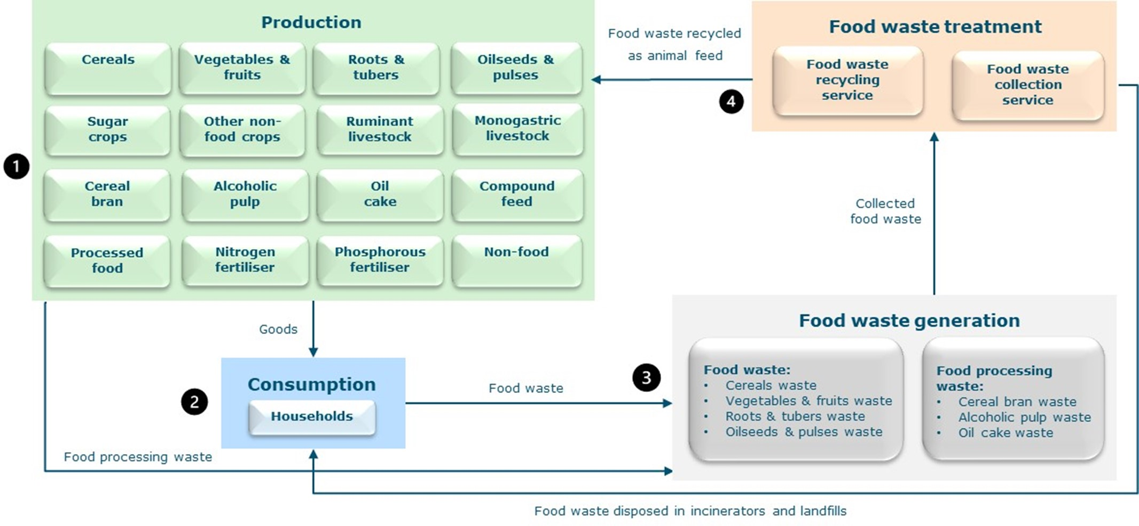

**Fig. 1 | Representation of the economy in China in the applied general equilibrium (AGE) framework with food waste and food processing waste.** The framework includes four parts: (1) Production; (2) Consumption; (3) Food waste generation; (4) Food waste treatment. The generated food waste is sent either to the ‘food waste recycling service’ sector or the ‘food waste collection service’ sector. The food waste recycling service sector recycles food waste as feed for monogastric livestock production. The food waste collection service sector collects food waste for landfill and incineration. The consumer price of food includes both the market price of food and the cost of collecting food waste. Livestock producers bear the cost of recycling food waste as feed. Detailed information is presented in Methods and Supplementary Information.

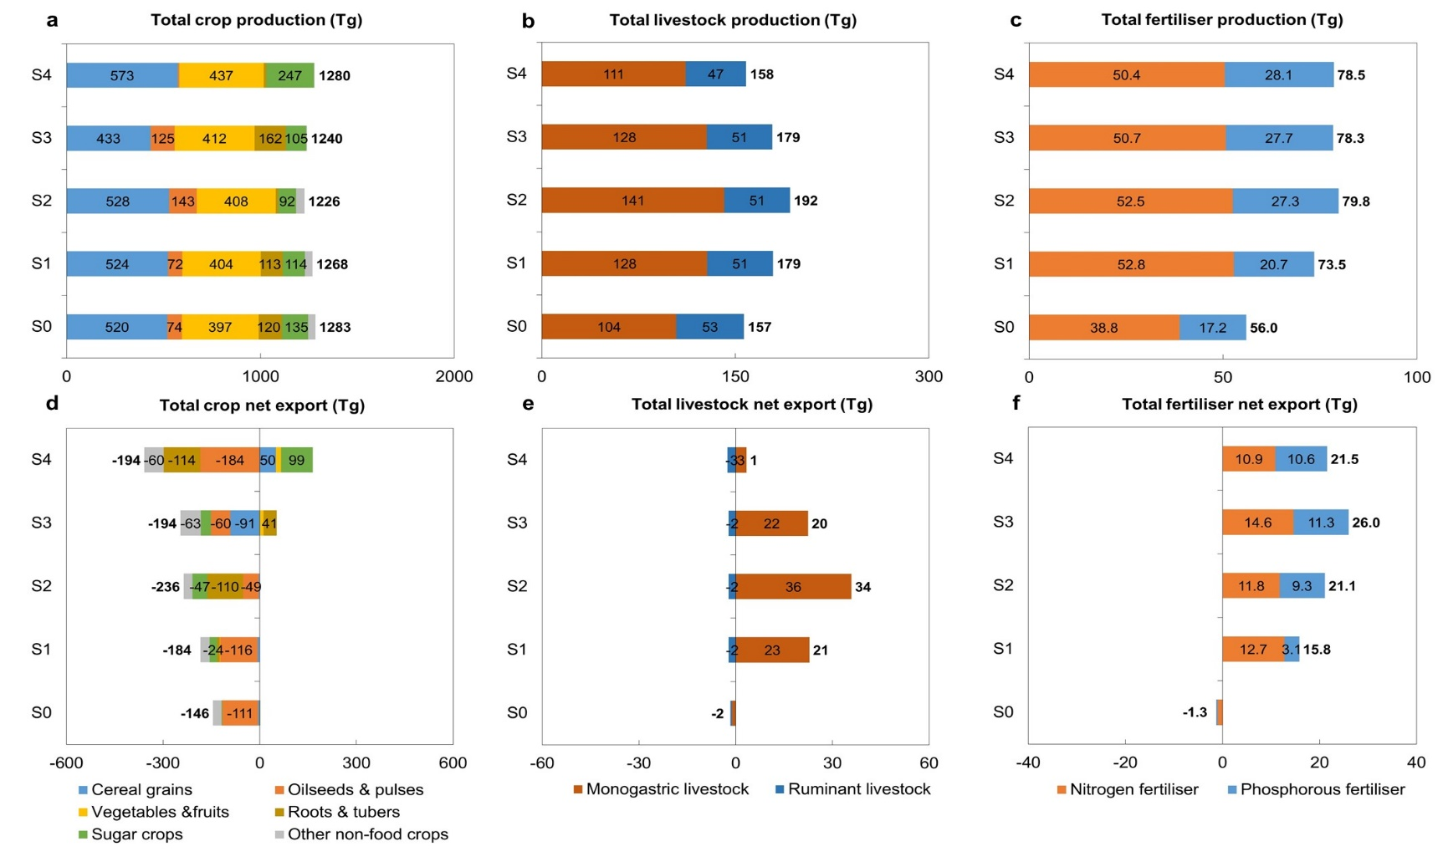

**Fig. 2 | Impacts of upcycling low–opportunity–cost feed products (LCFs) in China’s monogastric livestock as feed on domestic production and net export of total crop, livestock, and fertiliser.** Total (**a**) crop, (**b**) livestock, and (**c**) fertiliser production (Tg) in scenarios. Total (**d**) crop, (**e**) livestock, and (**f**) fertiliser net export (Tg) in scenarios. Total crop production exclude food waste and food processing by-products used by “food waste recycling service” and “food waste collection service” sectors (see Supplementary Table 4 for detailed data). Definitions of scenarios (S1 - ‘Partial use of LCFs as feed’; S2 - ‘Full use of LCFs as feed’; S3 - ‘S1 + A modest emission mitigation target’; S4 - ‘S1 + An ambitious emission mitigation target’) are described in Table 1.

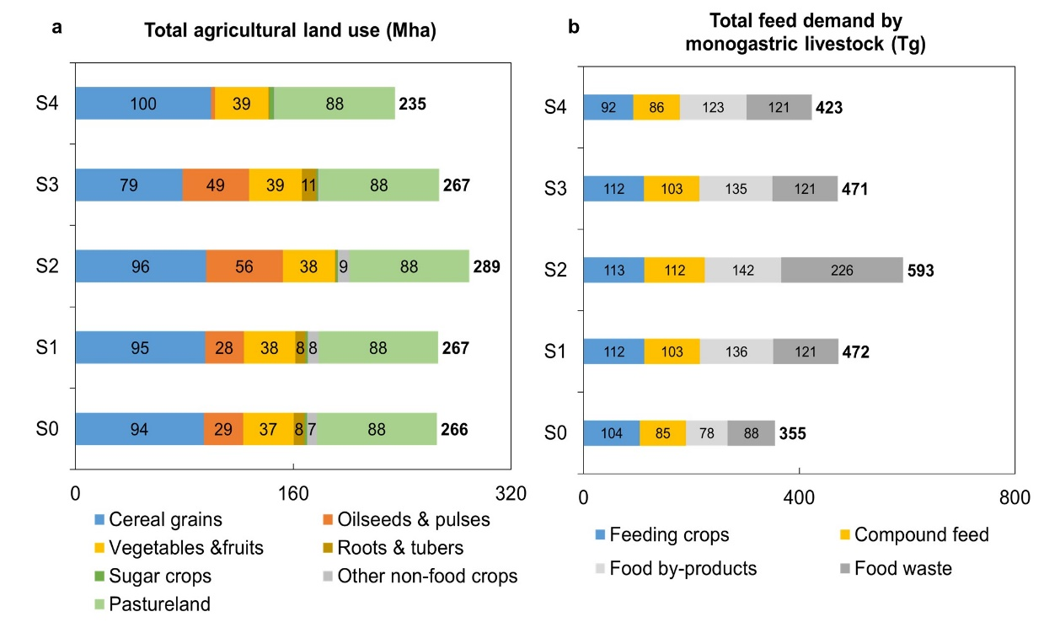

**Fig. 3 | Impacts of upcycling low–opportunity–cost feed products (LCFs) in China’s monogastric livestock as feed on domestic total agricultural land use and feed demand.** (**a**) Total agricultural land use (crop harvested area and pastureland) (Mha) and (**b**) feed demand by monogastric livestock (Tg) in scenarios. Definitions of scenarios (S1 - ‘Partial use of LCFs as feed’; S2 - ‘Full use of LCFs as feed’; S3 - ‘S1 + A modest emission mitigation target’; S4 - ‘S1 + An ambitious emission mitigation target’) are described in Table 1.

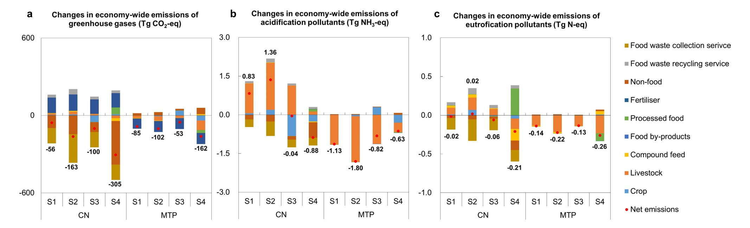

**Fig. 4 | Impacts of upcycling low–opportunity–cost feed products (LCFs) in China’s monogastric livestock as feed on economy-wide emissions in China (CN) and China’s main food and feed trading partners (MTP).** Changes in (**a**) economy-wide emissions of greenhouse gases (Tg CO2-eq), (**b**) acidification pollutants (Tg NH3-eq), and (**c**) eutrophication pollutants (Tg N-eq) in China and MTP in scenarios with respect to the baseline (S0). MTP includes Brazil, the United States, and Canada. Definitions of scenarios (S1 - ‘Partial use of LCFs as feed’; S2 - ‘Full use of LCFs as feed’; S3 - ‘S1 + A modest emission mitigation target’; S4 - ‘S1 + An ambitious emission mitigation target’) are described in Table 1.

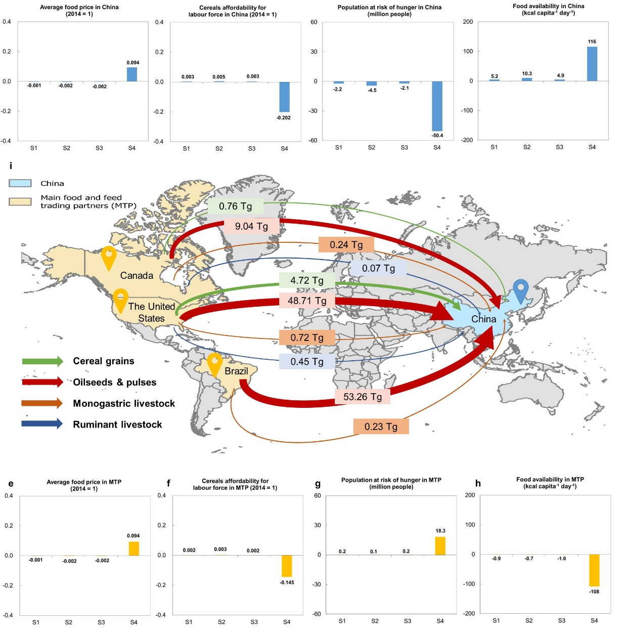

**Fig. 5 | Impacts of upcycling low–opportunity–cost feed products (LCFs) in monogastric livestock as feed on food security indicators in China (CN) and China’s main food and feed trading partners (MTP).** Changes in (**a**) average food (including primary food products and processed food) price, (**b**) cereals affordability for labour force, (**c**) population at risk of hunger (million people; S0 = 140.7 million people), and (**d**) food availability (kcal capita-1 day-1) in China in scenarios with respect to the baseline (S0). Changes in (**e**) average food (including primary food products and processed food) price, (**f**) cereals affordability for labour force, (**g**) population at risk of hunger (million people; S0 = 5.3 million people), and (**d**) food availability (kcal capita-1 day-1) in MTP in scenarios with respect to the baseline (S0). (**i**) Net imports (Tg) of main food and feed products from MTP to China in the baseline (S0). MTP includes Brazil, the United States, and Canada. According to the FAO approach, it is assumed that there is no risk of hunger for high-income countries; consequently, the population at risk of hunger is not applied to the United States and Canada 21,70,71. Definitions of scenarios (S1 - ‘Partial use of LCFs as feed’; S2 - ‘Full use of LCFs as feed’; S3 - ‘S1 + A modest emission mitigation target’; S4 - ‘S1 + An ambitious emission mitigation target’) are described in Table 1. Credit: World Countries base map, Esri (<https://hub.arcgis.com/datasets/esri::world-countries/about>).